INTEGRATIVE COURSE IN PSYCHOLOGY (ICOPSYCH)

ANALYSIS ON THE RESULT OF PRE-TEST EXAMINATION IN PSYCHOLOGICAL ASSESSMENT
MAY 10, 2025

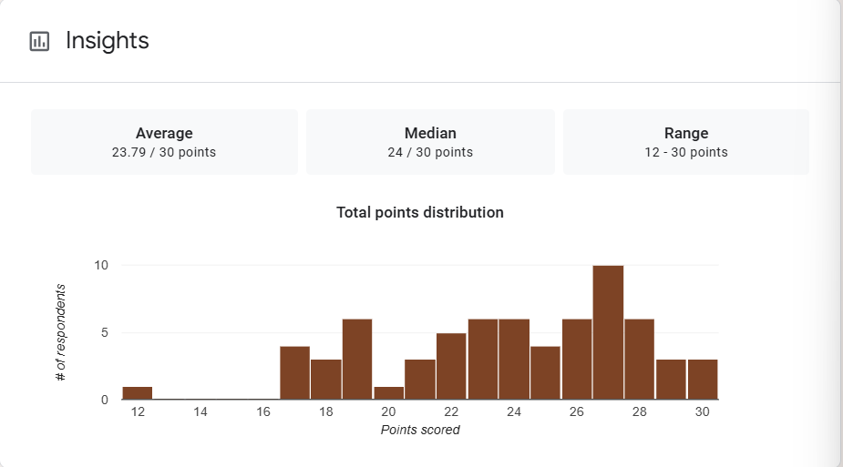

1. Mean Score: The mean score of 23.79 out of 30 equals approximately 79.3%, indicating that, on average, students performed well above average. This suggests strong overall understanding of the material or an exam that aligned well with students' preparation.

2. Median Score: The median score is 24 (80%), which is very close to the mean. This suggests that the data distribution is fairly symmetrical, with most students scoring near the average.

3. Range: This indicates a moderate range in performance. Most students did well, but a few scored significantly lower, suggesting some variation in individual understanding.

Interpretation Summary:

-The average performance was strong (79.3%), with the median (80%) confirming a consistent level of achievement across most students.

-The close mean and median suggest a balanced distribution with no significant skew.

-The range (12–30) reflects some variability, but with high scores dominating, indicating generally effective learning or test preparation.

-Overall, the results show a high level of student achievement, with only a small portion of the class needing targeted support.
RATIONALIZATION:

DIFFICULT QUESTIONS:

